
AI.NET Project: Challenge 1
Groep: (alleen)
- Kobe Vervoort: ACS 3AI01
Project: AllergyScan Screenshots
ScanPage2 | ScanPageResult2 | AllergiesPage
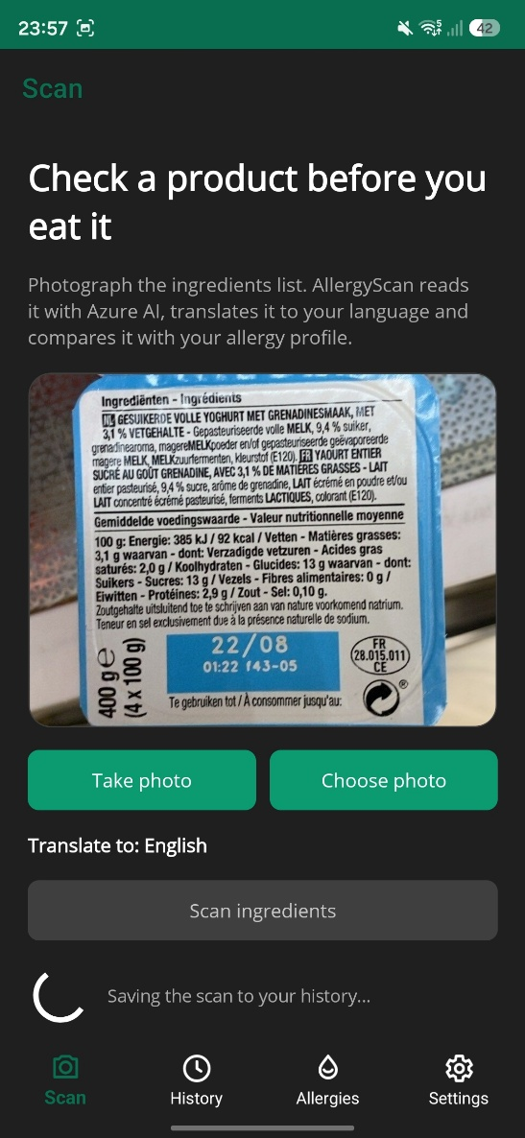 | 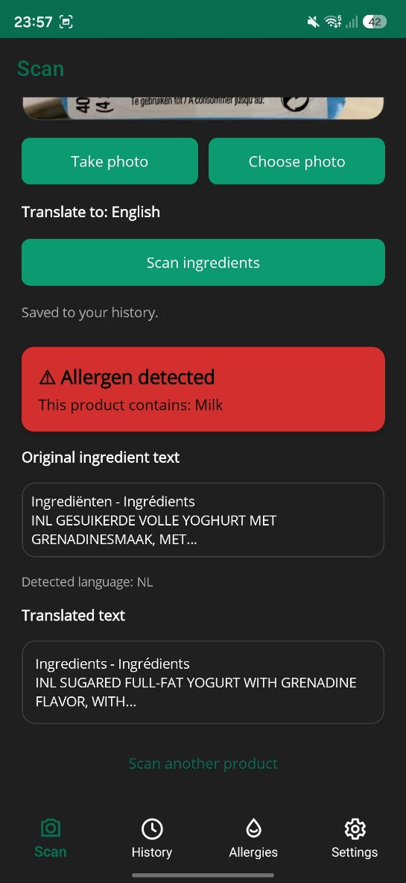 | 

